Are Jesus and Satan Brothers? Exodus: Gods & Kings Movie, Holy Trinity Explained 3 of 3
August 13, 2017
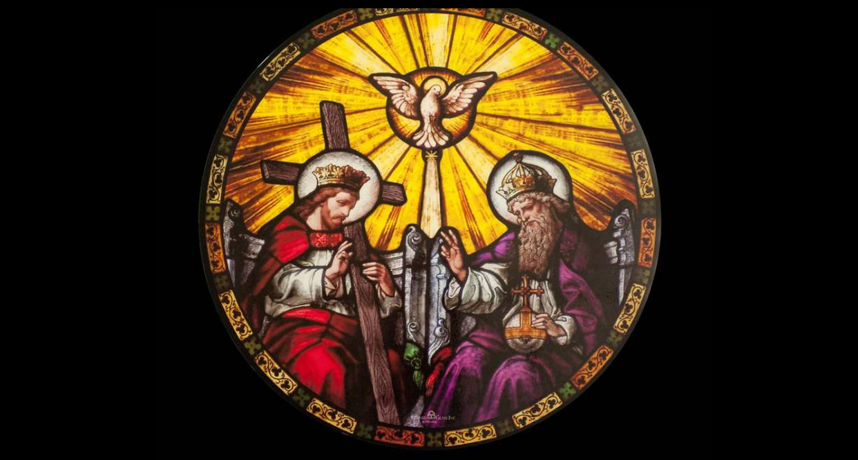
Now, I just want to take a moment in closing. Some people are very confused by the nature of the Trinity, and I like to explain it this way. In our essence we are spirit, eternal spirit, created by the Lord, by God. Yet we have another dimension, the soulish nature, which cannot be seen but can be felt by those who are sensitive. For instance, have you ever felt anger pouring out of someone even though they might be smiling on the outside? The soulish nature is in another dimension, and you can feel emotions coming off the soulish nature.

But then, we have a body that can be seen and felt, and that’s the physical nature.

Now, if you take an egg and show it to someone and ask them, "How many eggs do I have?" they will answer “One.” And that is correct. But if you break the egg open, there are yet two other parts: the white of the egg and the yoke. But even if you separate the three parts, it is still one egg.

Well, in the same way, the outer shell which is what you first see, can be likened to Jesus, the physical manifestation of God. The white could be likened to the Holy Spirit of God, and the yoke could be likened to Father God. All three are equal—yet they are still only One.

So, to say that Satan is Jesus’ brother, is ridiculous! Satan was created as an angel by God the Father, the Son, the Holy Spirit. Then he was thrown down from Heaven by God, exiled forever. And in his jealousy and fury, he came to make war with God’s other creations, specifically those are created in God's image: us. He can’t harm God directly, but by destroying the Earth, destroying families and children, he can hurt God. So, that’s why he is hell-bent on hurting and destroying everything good that God created.

Now let’s take a quick look at the new rendition of the film Exodus: Gods and Kings. There are so many inaccuracies in this movie it would take me days to explain them. But the Lord Jesus has asked me to defend His and the Father’s honor and make it clear that first of all, the person who wrote the script has NO idea who God is—unless he is deliberately misrepresenting Him.

I can tell you this much. His description of God fits perfectly with Satan’s personality and the multitude of New Age teachings including the Church of Satan.

The character of God the Father is portrayed as a sullen little boy, capricious and vindictive. Darkness is all around His personality, and an element of the bizarre in is His person - very much like the devil character played in The Passion. It's in every scene. There's a coldness and a darkness and a really bizarre feeling about every one of the scenes where supposedly God the Father appears as a child.

This is what Satan portrays God as. There is no basis in Scripture for this kind of description! As you can see from the comparison between The Lord and Satan, this figure in the movie most closely resembles Satan. Dark, vindictive, blood-thirsty, cold-hearted and distant.

Dear Ones, God is Love and in Him there is no darkness at all. Whoever made this film has taken the opportunity to mix truth with lies. This is the M.O. of Satan. The way that he functions: that's his M.O. Take the truth and mix it with lies and they won’t know the difference.

Well, that works for someone who has never encountered God or His love, but for true Christians, it does not work. Some of you are new to our channel and have not been given a good Bible-based instruction on who Our Lord truly is. How loving, gentle and kind He is and how only in extreme cases does He resort to violence to reach His ends. This is because Satan, working through man, withstands Him and one thing God is, is ALL POWERFUL AND MIGHTY. Righteous beyond any power in the universe.

How He hates to exercise that power, but there are cultural sins that cry out to Heaven for the innocent slain, to put a stop to what Satan is doing through evil men. When that happens, He comes out full force.

Still, time and time again the Lord gives Mercy when man repents and asks for mercy. Satan does not give mercy, as is witnessed through Allah who is portrayed to be the Merciful while beheading little children and ripping babies from their mother’s wombs.

And before I close, I want to mention what an incredible travesty that movie has done to the character of Moses, who was so meek and humbled when he became a shepherd, that he feared to speak out loud. And his brother Aaron had to speak for him on many occasions. It was not Moses' sword that that convinced Pharoah; it was the power of God acting through a quiet and meek personality.

I have had the privilege of meeting Moses in Heaven and he is by far the most meek person I have ever met. But don’t take my word for it.

In Numbers 12:4-9 Scripture says “Now Moses was a very humble man, more humble than anyone else on the face of the earth.

At once the Lord said to Moses, Aaron and Miriam, “Come out to the tent of meeting, all three of you.” So the three of them went out. Then the Lord came down in a pillar of cloud; he stood at the entrance to the tent and summoned Aaron and Miriam. When the two of them stepped forward, he said, “Listen to my words:

“When there is a prophet among you, I, the Lord, reveal myself to them in visions, I speak to them in dreams. But this is not true of my servant Moses; he is faithful in all my house. With him I speak face to face, clearly and not in riddles; he sees the form of the Lord. Why then were you not afraid to speak against my servant Moses?” The anger of the Lord burned against them.

Well, after that, when the cloud lifted, Miriam was struck with leprosy. And of course, Moses—being incredibly merciful and loving, begged God to take the leprosy away from her.

So, my dear ones, be very, very careful when people tell you who God is, or portray Him in the movies. Unless that description is faithful to the Scriptures, it cannot be trusted, because the devils take truth and lace it with lies to deceive us.

So, if you spot a lie mixed in with the truth, you are NOT dealing with holiness. You're dealing with the deceiver.

In conclusion, I just want to say: Jesus is NOT Satan’s brother. Satan was created by God—the Triune God, Father, Son and Holy Spirit—to lead worship in Heaven. And in the end, the fire coming from the mouth of Jesus Our Lord will destroy all his armies and they will be cast into a bed of torments.

Thanks for bearing with me on this teaching. I had to ask Jesus, "Do you have anything to add?"

And He began, “My dear children, I and My Father are One in the same. With Love and tenderness we lead our children. but should tyrants arise to destroy and maim the innocent, We will resort to the measures necessary to put an end to it. Satan is a liar. And for you poor ones that are trapped in his influence right now, I plead with you to repent, come to Me and I will protect you. You are serving a liar who is promising you outrageous things.

"On Earth, he is capable of giving you everything you want. But when you die, he will drag you screaming down into a chamber of torture that has been prepared for you. This is not My will. My prayer for you is that you repent before it is too late.

"And for you, My young ones, who are just learning about Who I Am—let no one deceive you. I am a God of love and mercy and I am vulnerable to your sorrows. Though these things are the result of your wrong choices in life, I cry when you hurt, I long to hold and forgive you, and to make all things new.

“Please, do not believe everything you hear. Just because someone had millions of dollars supplied to them to create films that slander Our character, do not base your beliefs on any movie, book or teaching that goes against what I have left behind for you in the Sacred Holy Scriptures. Weigh everything against what I have taught you, and outwit the devils who are counting on your youth and gullibility to cause you to believe lies about Me. There is no more time left to live lies! Live in the light and in the truth, no matter how difficult it might be to accept what is written. It is your life line to Heaven and will preserve your souls.

“Be wise as serpents and gentle as doves."

And that was the end of His message.

Well, Heartdwellers, I just want to thank you for your prayers and support. We have been given a sacred trust to reveal the true loving character of God to the world wide web and we cannot do it without your prayers and offerings.

Summer time (and Christmas) are typically very skinny in donations and we sometimes have to cut back on essentials to see to it that everyone gets paid. But because of your generosity every month, we are able to keep going.

I thank you from the bottom of my heart and want you to know that, every soul that is saved from Hell through this ministry, because of your loving support—you will receive credit for in Heaven. It’s not about me or Ezekiel or us. It’s about all of us together who make it possible to reach others around the world. We all have our part to play. Thank you so very much for being faithful with yours.

